TOUCH SCREEN PLANT DATA COLLECTION SECURITY.

If you want to lock your users out of changing the times, then set security so they can view, but not update. Note, that when the security is set by user, the user cannot click the buttons to change the hour, minute, pm, set the time or reset the time. If they are late to work, they cannot change the start time.

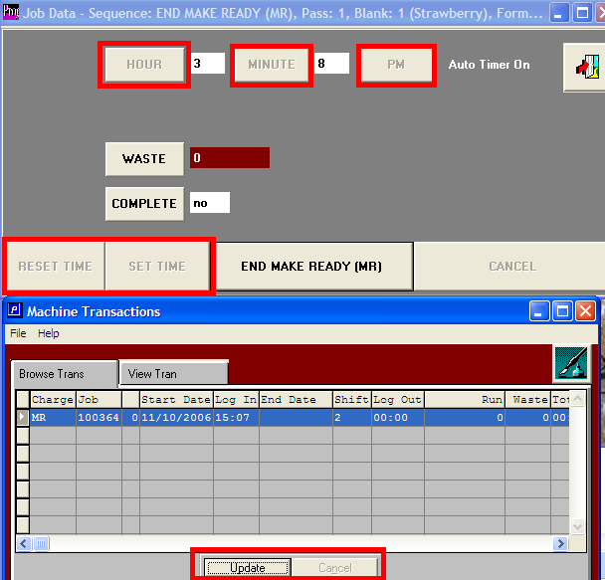

From the Addon main menu, access the program master security.

